TFS #95359

TEST - CW 17, 27: Please Make Partial Releases Editable (INC0160881)

Kevin Geissler

10/03/2016

Table of Contents

TFS # 1

Description 2

Testing Notes 2

Screen Shots and Steps Taken 2

# Description

Reported by Kari Seidel in INC0160881:

AgC has expressed concern about the fact that once a partial release is keyed, it cannot be modified. It cannot be modified even if the scenario is still open. If you miss key a value, want to modify the legal language, or have even a spelling mistake, you cannot go back to adjust it. I would assume the only options you have at that point are to delete the scenario and start over (if your scenario isn't already submitted), or delete and rekey your collateral? Either way you are losing work.

Also on Enhancement list:

#27 (AgC): Cannot edit partial release after leaving wizard Description: Unable to edit the PR after leaving the wizard, even if it has not been submitted. The only option if it hasn’t submitted is to delete the scenario and start over.

#17 (FCW): Partial Release – Editing a historical Partial Release; there is no way to complete this without having to delete the collateral icon and re-add the collateral and input the correct partial release value.

Suggested Solution from Enhancement list:

​Make the Partial Release History Panel Editable, even allowing for deletion of Partial Release and have that add back to Collateral Value/Acres. But you cant unreleased detail components, only edit them.  Un-Releasing or allowing the editing of summary only releases would be possible as we would only need to unwind part of the information.

# Testing Notes

Notes for testing:

This item is fairly small for development, but larger on the testing end.  We need to test various scenarios that lock down editing on the screen including security and certain LOS statuses (depending on ACA configs).

BCM 9/9/16 - Question 1: If you add a partial release to summary level collateral item, and then add detail to that item afterwards, should the partial release be editable? NO.

Question 2: Should you be able to do a partial release on new collateral items that have not yet been submitted? NO

Question 3: Should you be able to do a partial release on new detail level collateral that has not yet been submitted? NO - should gray out checkbox, if possible. Maybe have a tooltip that says this is new collateral that cannot be released, OR, maybe have text "NEW!" somewhere on the new detail row(s).

ALSO: Instead of editing directly in the History grid, add an “edit” hyperlink to each row in the grid which would bring you back to the New tab with all the fields populated by the row you’re editing. Clicking “edit” would cause the tab to be renamed “Edit Partial Release.” This has the added benefit of showing the user the Current Collateral Market Value and New Collateral Market Value while they’re editing the partial release.

RMW 9/27/16: Despite attempts to allow it, this item DOES NOT allow users to "unrelease" collateral components that were released in detail partial release mode.

## Screen Shots and Steps Taken

**KPG 10/04/2016 – Partial releases on the summary level can now be edited. New collateral cannot have a partial release. If a partial release is made prior to new detail being added, the partial release cannot be edited.**

**“Cancel” on the “Confirm Delete” alert is not deleting the partial release, but it is deleting it from the partial release history. Refreshing the scenario displays the partial release in the history.**

Opened the Partial Release Smart Data Wizard for a piece of collateral. Entered the **Market Value being released as $100,000** and clicked SAVE.

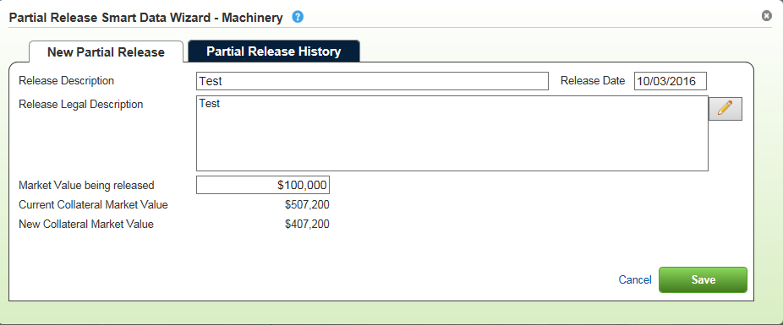

Reopened the Partial Release Smart Data Wizard and viewed the Partial Release History. The **“edit” link** appears to the left of the row.

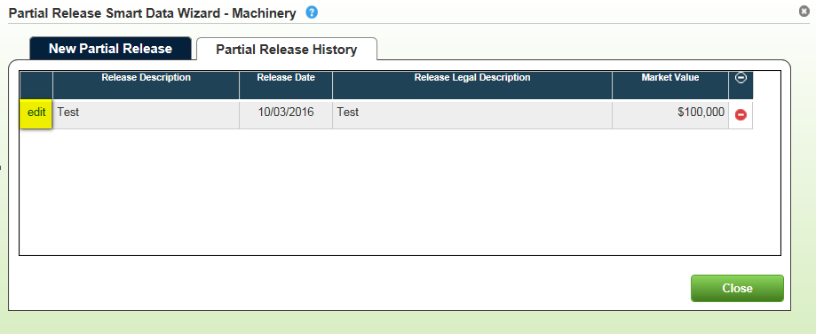

In the “Edit Partial Release” tab, you are able to successfully edit Release Description, Release Legal Description, and the Market Value being released.

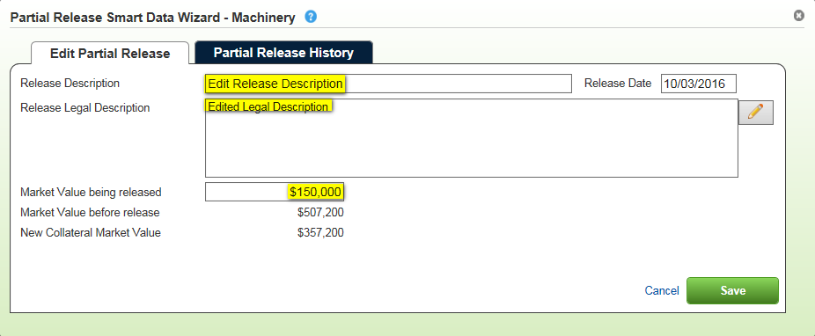

The Partial Release edits saved successfully.

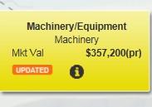

Selecting Partial Release History has the delete icon on the right side of the row.

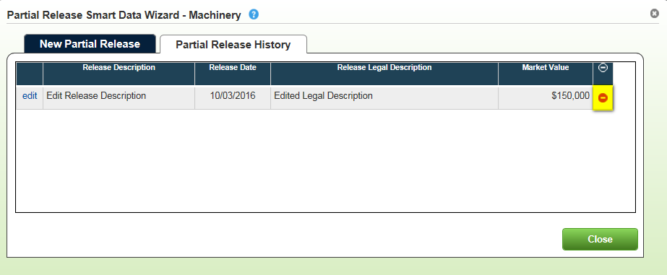

The “Confirm Delete” alert appears.

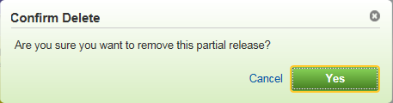

After selecting “Yes”, the partial release was successfully deleted.

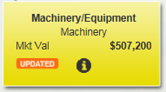

When selecting “Cancel”, the partial release is **not deleted**. However, it does **not** show the partial release on the Partial Release History. To view the Partial Release History, you must refresh the scenario and go back into the modal.

Below, you can see a partial release was made but does not appear in the history.

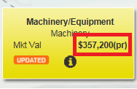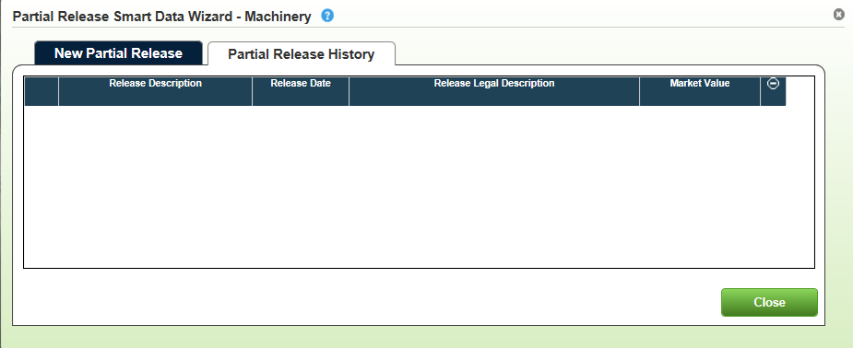

To recreate:

1. Make a partial release and go to Partial Release History
2. Click the red delete icon, then select “Cancel”
3. Go back to Partial Release History
4. The partial release is NOT deleted, but it is not listed in the history
5. Refresh the scenario and go back to the Partial Release History
6. The partial release appears again

In collateral with multiple detail levels, you can check the detail level you would like to release.

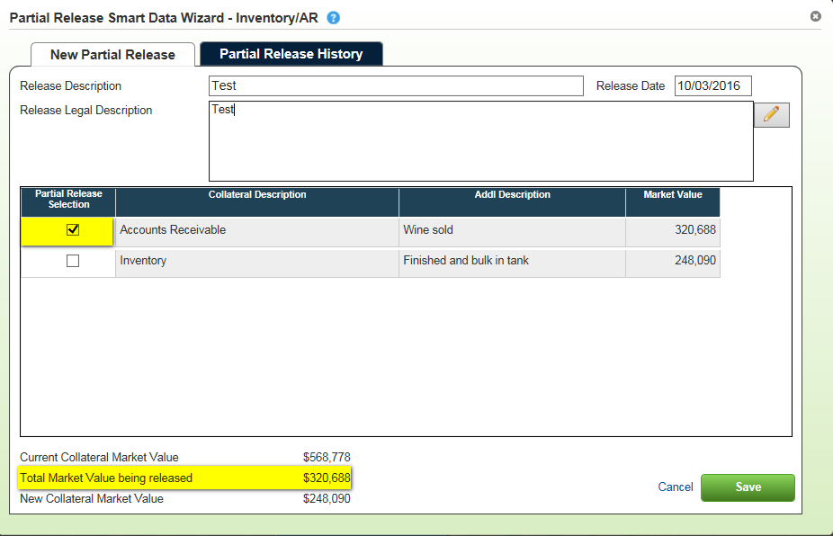

After saving, the partial release selection is READ ONLY and cannot be edited.

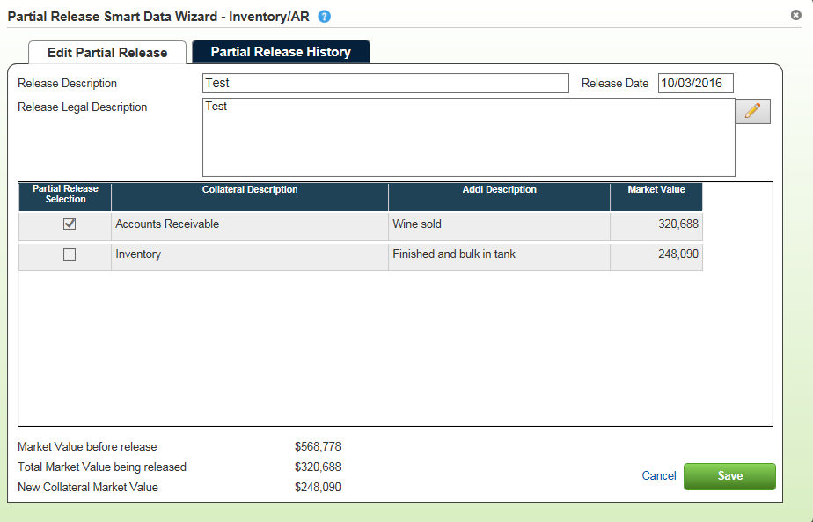

In Partial Release History, the red delete icon does not appear to delete the partial release made to the detail item.

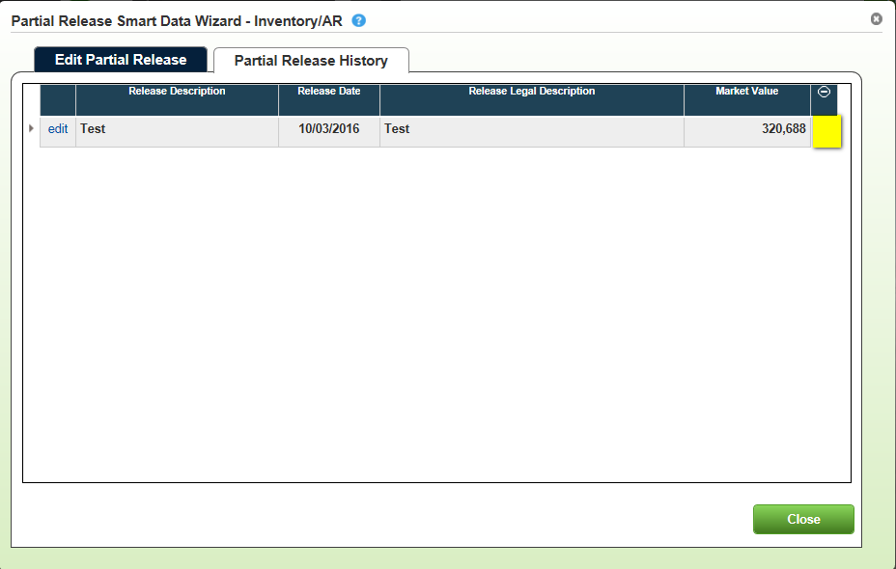

When saving a partial release to a piece of collateral, you do NOT have the ability to make a partial release after adding detail afterwards. The row is READ ONLY.

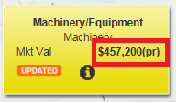

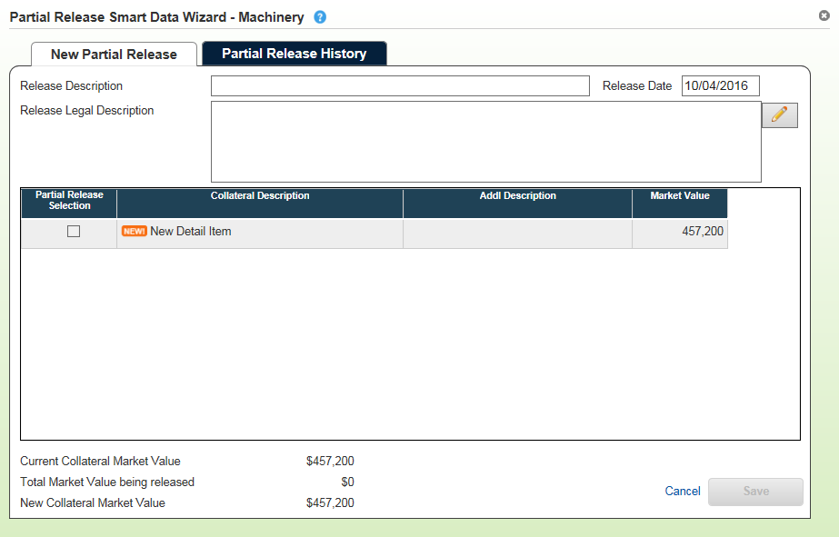

When detail is added to collateral, you cannot make a partial release. The “NEW!” icon appears as a notification. The row is READ ONLY.

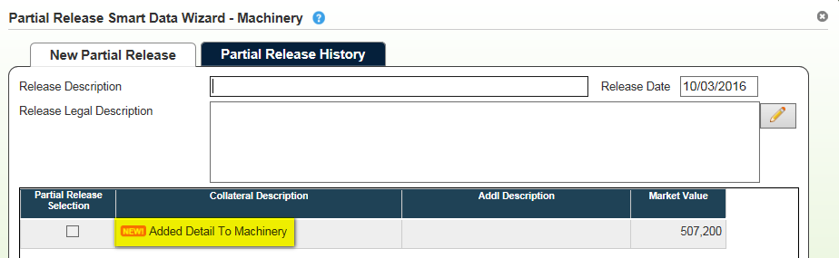

When adding a new piece of collateral, you do NOT have the ability to do a partial release.



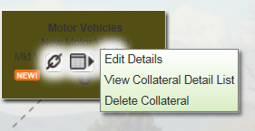

The scenario successfully submitted to EmPOWER

